- Launch one EC2 instance using Amazon Linux 2.
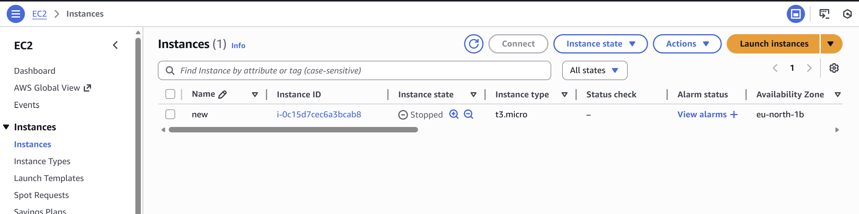

- Install Docker.
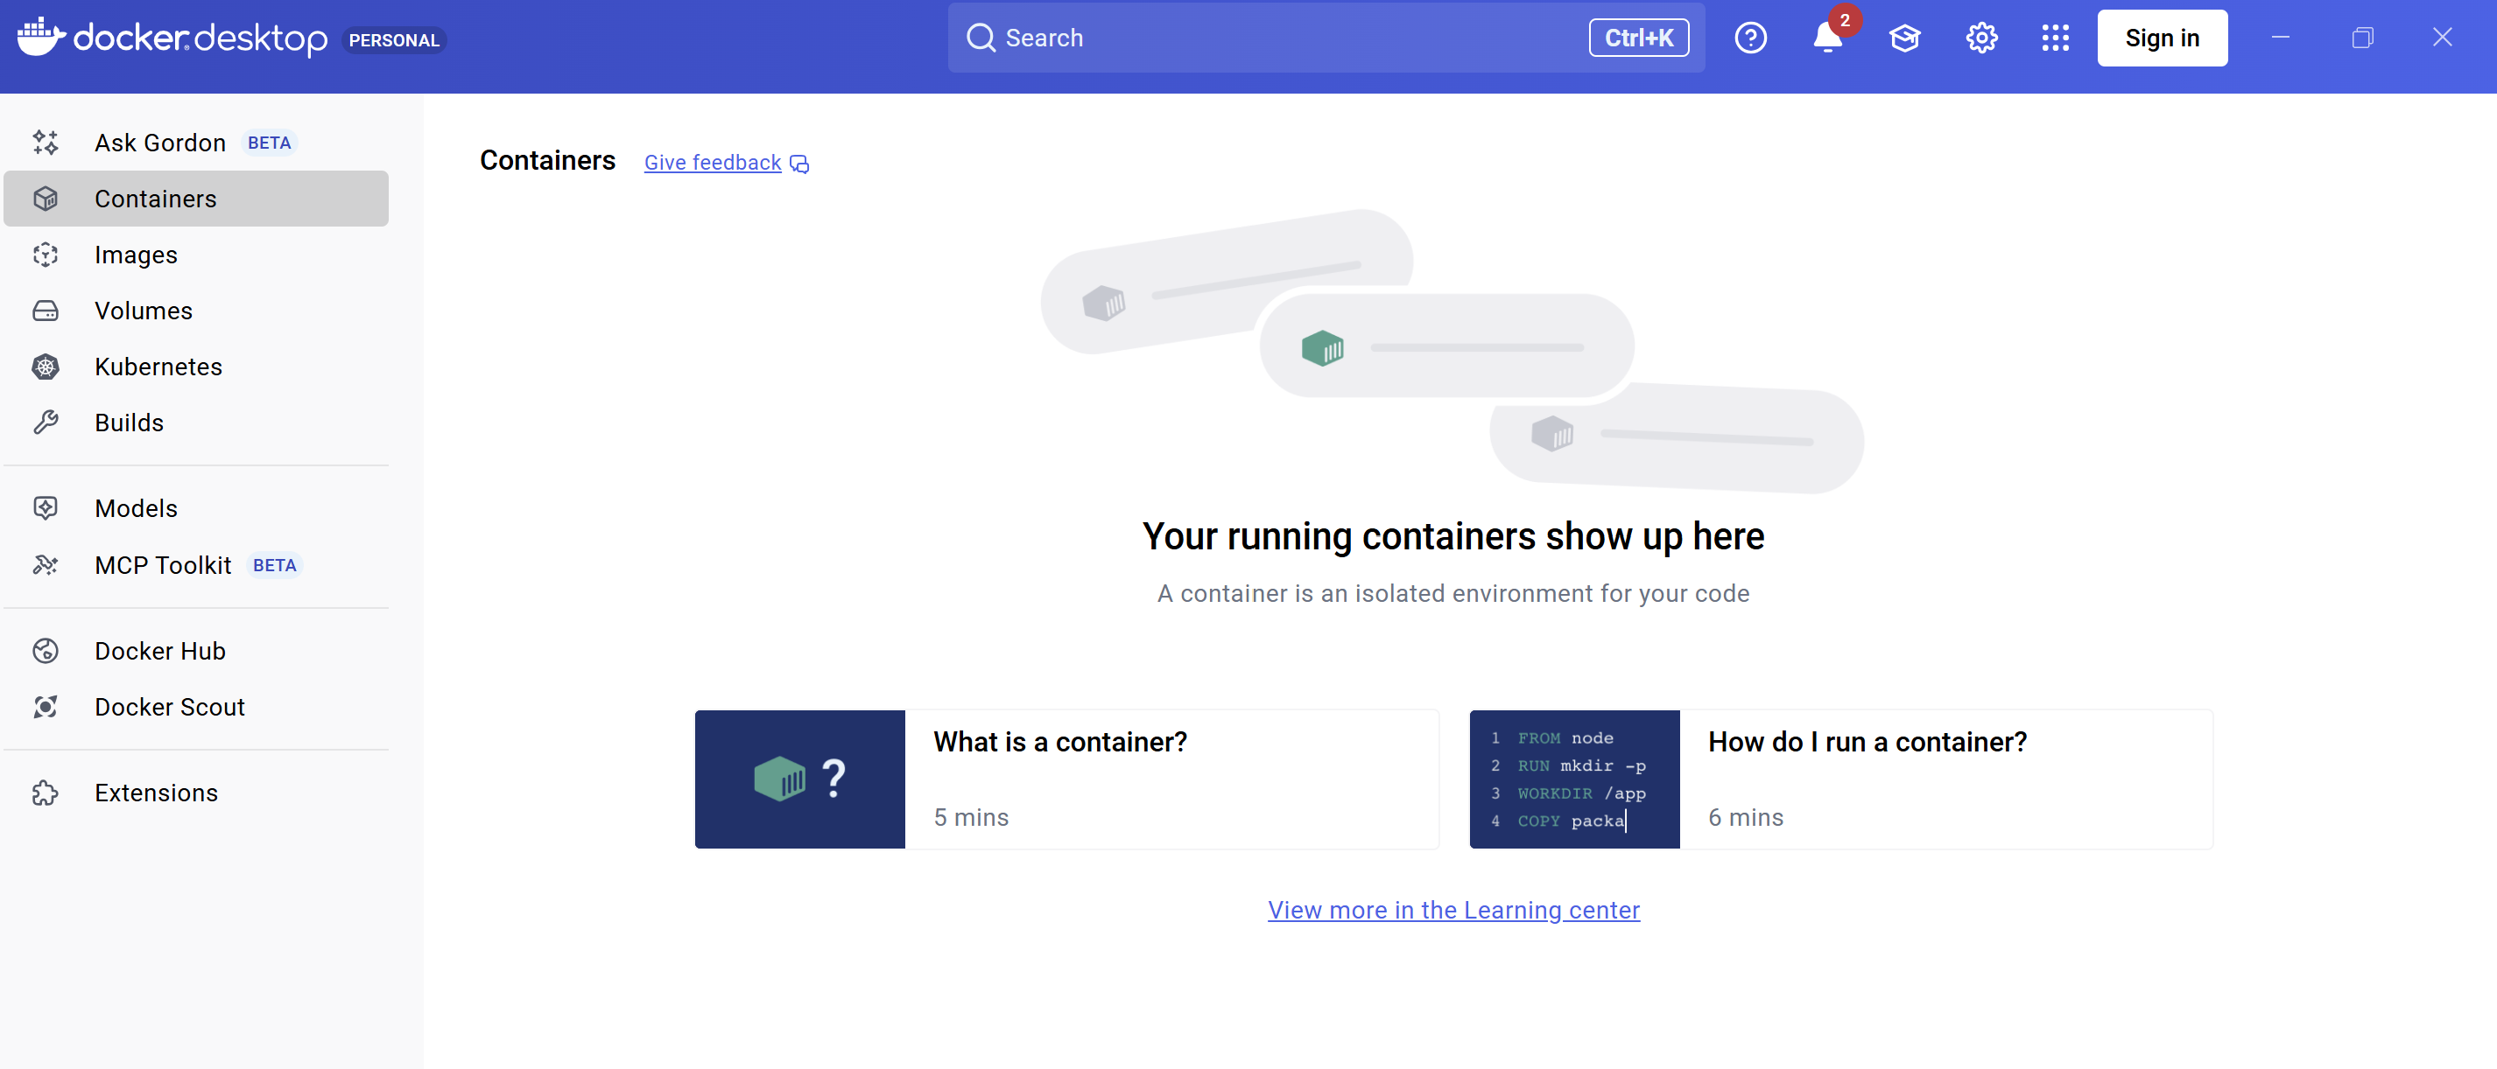
- Install Jenkins
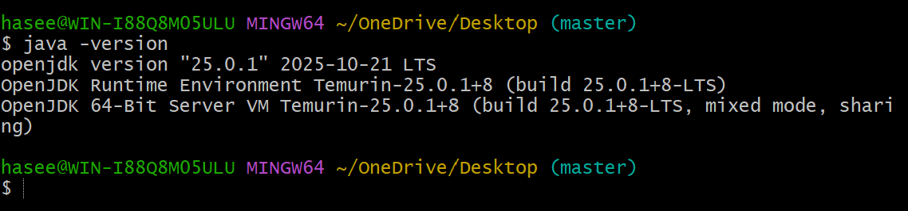

- Install Apache.
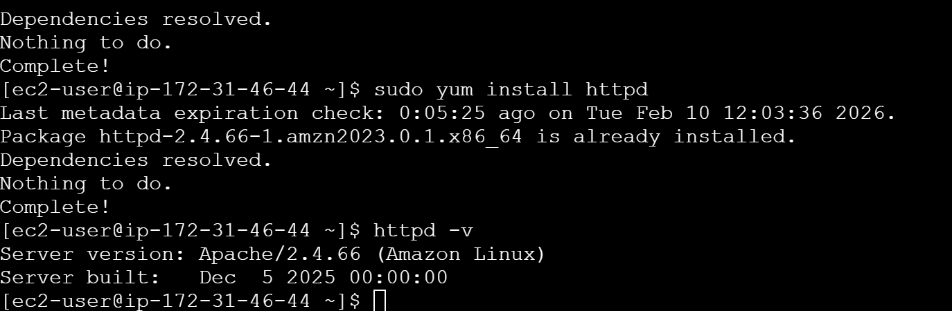
- Install Nginx.
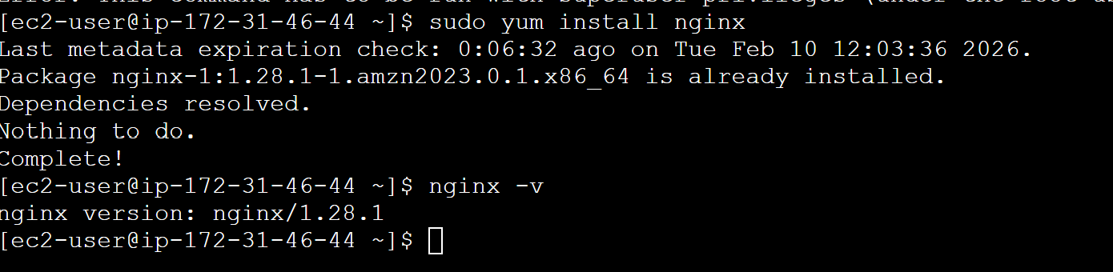

- Install Apache Tomcat
